OBSERVING TRANSITS OF EXTRASOLAR PLANETS USING THE NFO WEBSCOPE: OBSERVATION OF THE PLANET HD 209458B AND PROPOSED OBSERVATION OF THE PLANET TRES-1B. Rozmin K. Daya^{1,2,3}, Claud H. Sandberg Lacy^{1,4}, ¹Arkansas Center for Space and Planetary Sciences, University of Arkansas, Fayetteville, Arkansas, 72701, ²Department of Physics, Southern Methodist University, Dallas, Texas, 75275, ³Department of Mathematics, Southern Methodist University, Dallas, Texas, 75275, ⁴Department of Physics and Astronomy, University of Arkansas, Fayetteville, Arkansas, 72701, rdaya@smu.edu.

Introduction: A large number of extrasolar planets has been detected in recent years using the transit technique, a method whereby the event of a planet crossing in front of its parent star is observed and analyzed, yielding information about the planet’s orbital period, radius, mass, density and distance from its star. Planets have been detected by this method using a variety of telescopes. With this project, we propose to establish whether or not the NFO telescope in Silver City, New Mexico is a viable tool for planet detection via the transit technique. For this to be the case, we require a high level of accuracy in observations, as the transits of planets are shallow. If this telescope is in fact an effective tool for this type of research, we hope to improve on the orbital elements of two extrasolar planets known to be transiting: HD 209458b and TrES-1b.
Details of the Method. The transits of the planets will be photographed and the images measured, yielding light curves for the parent stars. These light curves can then be analyzed to obtain the desired orbital information for the planet in question, stipulated that at least one full transit is observed. We have completed one observation of a partial transit of HD 209458b and have constructed the associated light curves (partial curves in this case); one for each color the star was observed in.
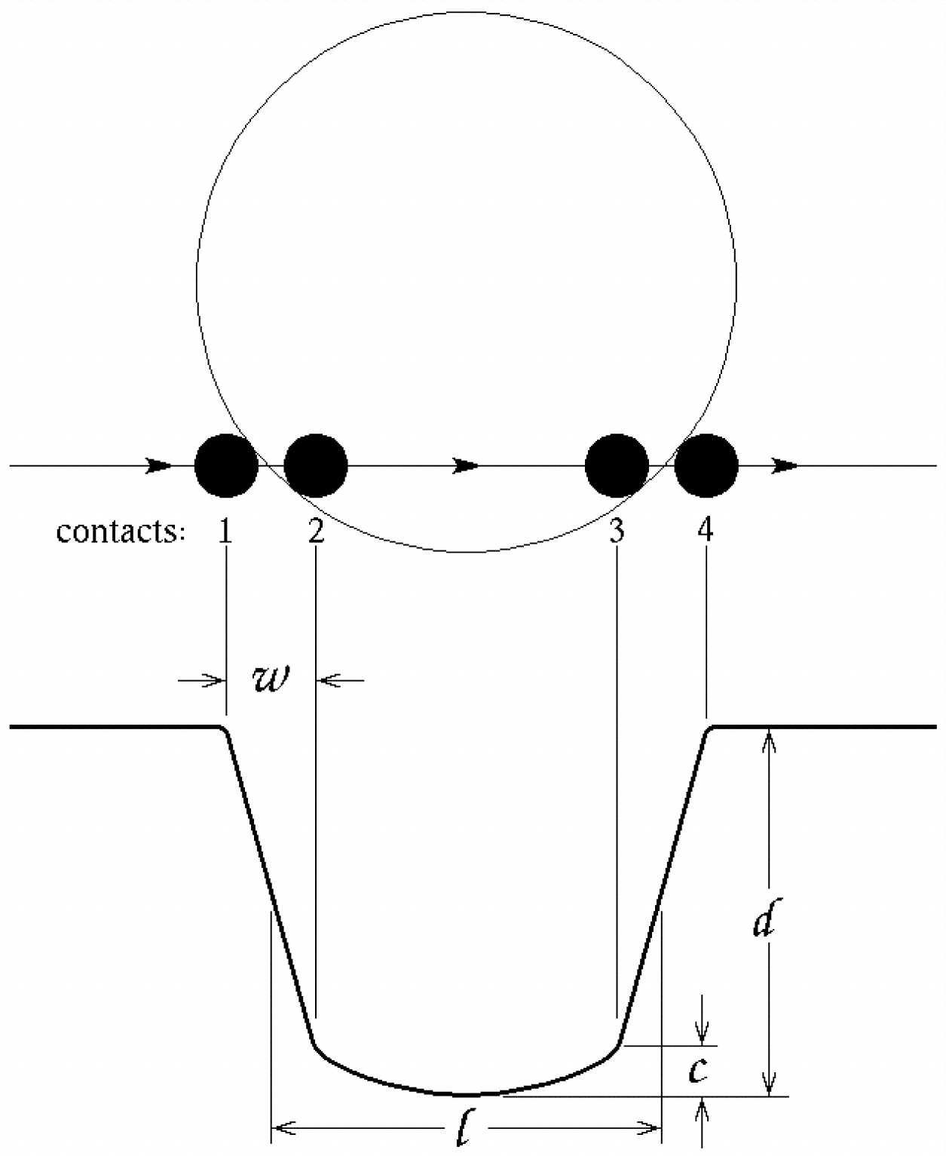
Fig. 1. “Schematic illustration of the light curve of a transiting planet. Measurable quantities: duration of the transit l, the transit depth d, the ingress/egress duration w, and the central curvature of the light curve C.”¹

Preliminary Step: Identifying Candidates for Observation. Our first step was to identify planets for observation. We required that the planet(s) be known to transit, have a declination greater than -30 degrees, and have a period short enough such that a transit could be observed at least 4 times during the 10 week REU program. We used the database at www.transitsearch.org to locate candidates with suitable periods and declinations, and then did a follow up search of journal articles, predominantly from the Astronomical Journal and the Astrophysical Journal, to determine which of these planets had been observed transiting their stars. HD 209458b and TrES-1b were the only planets meeting the observational requirements that were found to definitely be transiting.

Observations: Dr. Lacy’s program, Specob, was used to determine when the planets would transit their stars. We then set up the NFO telescope to take a series of images during this the transit window and an hour before and after the window. For HD 209458, observations were made using B, V, and R filters. Exposure times were 25 seconds in B, 6 seconds in V and 4 seconds in R. For TrES-1, we propose observations using the R filter and a 300 second exposure time.
The NFO Telescope. The NFO telescope uses a 24 inch Cassegrain reflector with a 2K by 2K CCD camera on the back end. The bias and dark frames are taken each morning following evening observations. Ten bias images are taken with zero seconds of integration. The 4th from the lowest value is kept as the value for the bias. Then 10 dark frames are taken with a 120 second integration. The bias value is subtracted from each frame, then the dark field is processed as above. The flats are taken in the evening twilight. They are taken in each filter, with the telescope pointed at the vertex. The flat fields are normalized to 10000 digital units. The entire field is averaged, then 10000 / average is multiplied times each pixel. The top respective pixel value is thrown out. The second lowest pixel value is used as the image value. The star images first have the bias subtracted. Then they have the dark * exposure / 120, subtracted. If any pixel is less than zero it is set to zero. Then they are multiplied by 10000 and divided by the flat. Finally, 5 DU's are added.³

Measuring the Images and Creating Light Curves: The images are measured using the program NFO Measure. First the user must select an image from the series and identify a pattern, selecting the variable star and two comparison stars. Next, the series is measured using this pattern and the program constructs a light curve for the star.
HD 209458. A series of images was obtained 07-15-2005 UT.
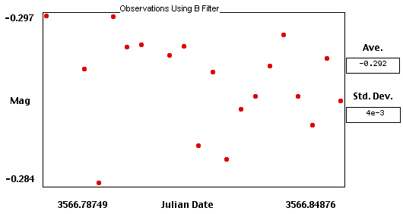
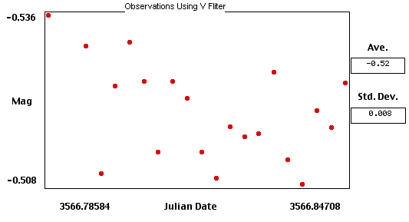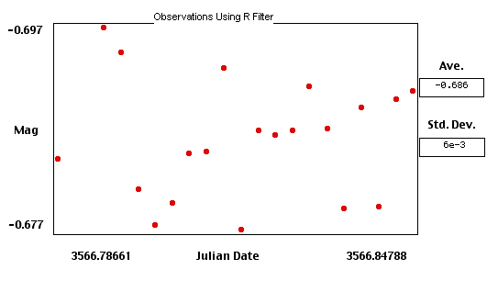Fig. 2. Light curves for the star HD 209458 during the transit of its planet. The curves were constructed using NFO measure.

TrES-1. We have not obtained images of TrES-1, and thus have not constructed any of our own light curves for the star. Below are light curves² created using images from telescopes in the Trans-Atlantic Exoplanet Survey (TrES) Network.
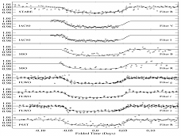
Fig. 3. Light curves for TrES-1. The curves were constructed using images from various telescopes in the Trans-Atlantic Exoplanet Survey (TrES) network.

Orbital Elements: We have not yet independently calculated orbital elements for either planet due to a lack of data at this point. However, orbital data for both planets is included below, for reference.

Parameter Value
P (orbital period)………………….3.52480 ± 0.00004 days
R_{p} (planetary radius)……………. 1.347 ± 0.060 R_{Jup}
i (orbital inclination)...................... 866 ± 014
R* (stellar radius)............................1.146 ± 0.050 R
T_{c} (time at center of transit).......2451659.93675 ± 0.0001 HJD
Fig. 4. Table displaying orbital information for HD 209458b.¹

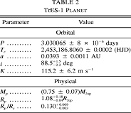
Fig. 5. Table displaying orbital information for TrES-1b.²

Conclusions: Based on the very low standard deviations associated with our data, we conclude that the NFO telescope is capable of observing with a sufficiently high accuracy to be able to observe the transits of extrasolar planets. Although the event of the transit is not clearly visible in our light curves, this is not because the observations are inaccurate; it is because the part of the transit we were able to view was the middle portion. The graphs fit our expectations of a straight distribution of data points characteristic of the bottom portion of a light curve during a transit.

Acknowledgements: We would like to thank the state of Arkansas and NASA for funding.

References: [1] Brown, T. M., Charbonneau, D., Gilliland, R. L., Noyes, R. W., & Burrows, A. 2001, Astrophysical Journal, 552, 699. [2] Alonso et al., Astrophysical Jouranal Letters, 613, L153. [3] Neely, B. Obtained from NFO website.

