Space Weathering Effects: Implications for Solar Wind and Airless Bodies.
S. Beard sky@purdue.edu, V. Chevrier vchevrie@uark.edu , Arkansas Center for Space and Planetary Sciences, University of Arkansas, Fayetteville, AR 72701

Introduction: Space weathering is a term given to the process of altering the surface of an object void of an atmosphere [1].This is done by various possible methods but mainly from solar wind ion bombardment and micrometeorite impacts [2]. This is known to affect the surface of the moon by changing the composition through physical and chemical changes that cause the surface to darken, redden its spectrum, and weaken its absorption bands [3]. Space weathering happens on the moon, but weather or not it occurs on other bodies in the solar system or if in the same way, is still highly debated. A point of interest is NEAR Shoemaker’s X-Ray and Gamma-Ray spectrums of the asteroid Eros. The spectrum taken highly resembles that of ordinary chondritic meteorites with a significant depletion of sulfur, which many attribute to the effects of space weathering [4].Our objective was to expose samples to plasma that simulates solar wind, observe the changes that occurred, and conclude whether or not they are consistent with space weathering.

Method: A Technics Hummer II Sputter Coater is used to create plasma with Argon Ions at ~2 keV potential. Samples are placed on Al foil holders and placed in a vacuum which is pumped down to 75 mTorr. The plasma is maintained at 20 mAmps for desired time. Samples used include anorthosite- CaAl₂Si₂O_{8,} olivine- Mg₂SiO_{4,} troilite- FeS, and alumina- Al₂O₃. Spectrums are taken before and after irradiation with a Nicolet 6700 Fourier Transform Infrared (FTIR) Spectrometer in the NIR. Philips Type PW 1830 X-Ray Diffraction (XRD) run at 45 kV and 40 mAmps, and Philips Model XL30 Environmental Scanning Electron Microscope (ESEM) run under high vacuum and at 10 and 15 keV are used to determine changes in crystalline structure and to take chemical analysis.

Results/Observations: Samples became darker with time (Fig. 1) except for possibly troilite, which is black. All samples exhibited darkening on the surface, except for troilite. Spectrums taken for all samples show shallower and broader features compared to the unexposed spectrum, which generally shows more affect as exposure time increases (Fig. 2). Anorthosite, the only sample run in the XRD so far, shows a large amount of destruction of the crystalline structure (Fig. 3). Initial troilite ESEM results indicate a bad sample due to other compounds present in the sample including magnetite, therefore results are inconclusive.

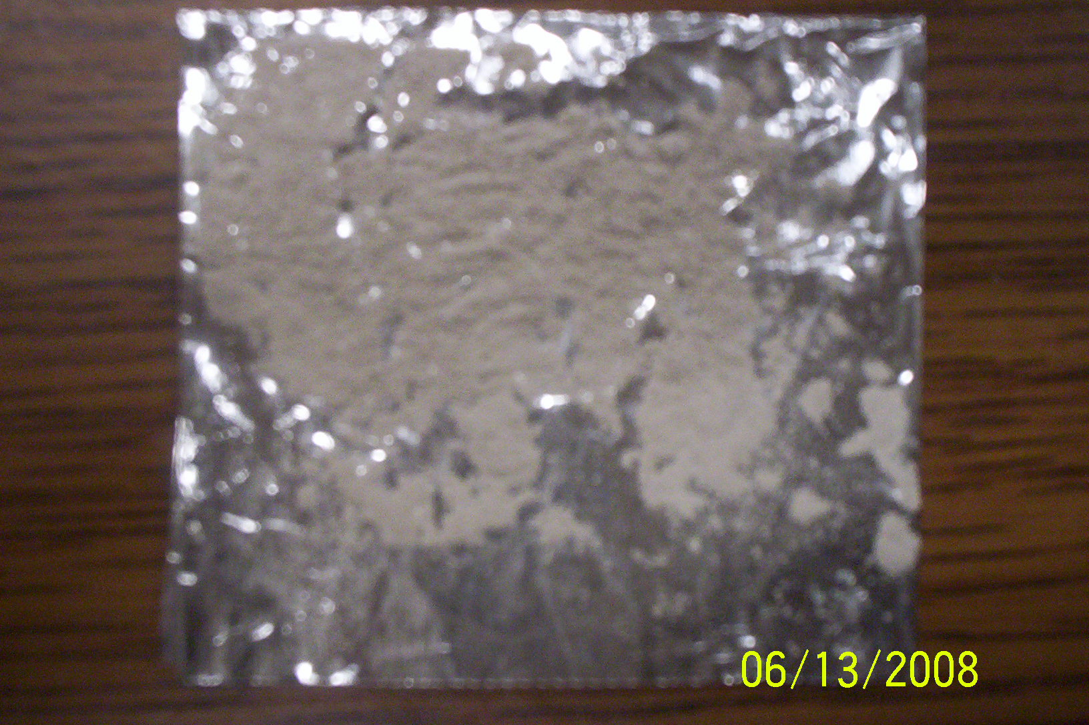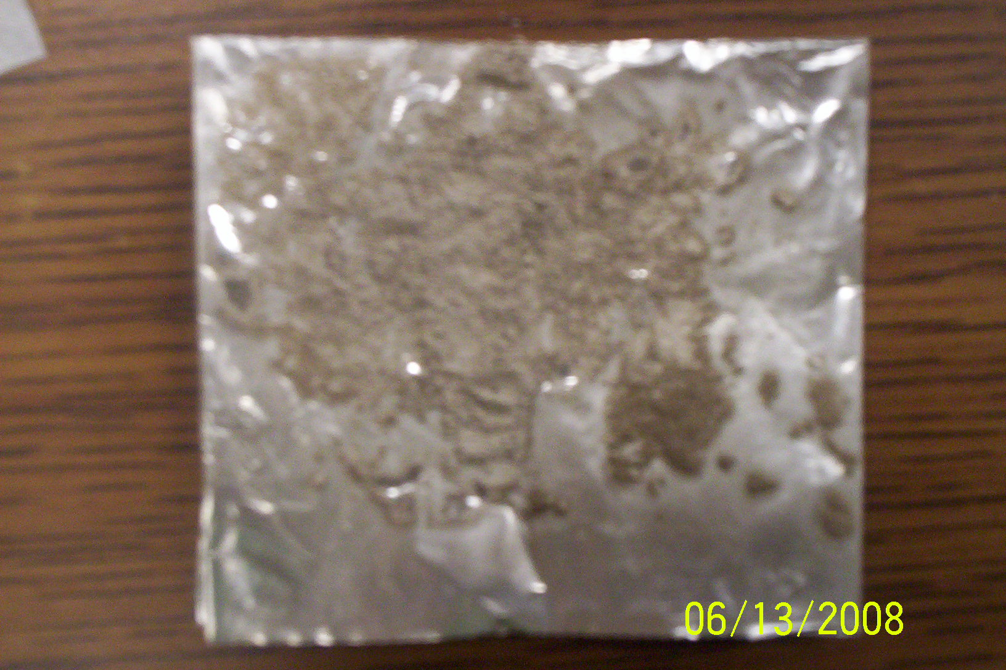
Fig. 1: Anorthosite before (left) and after (right)
plasma exposure.

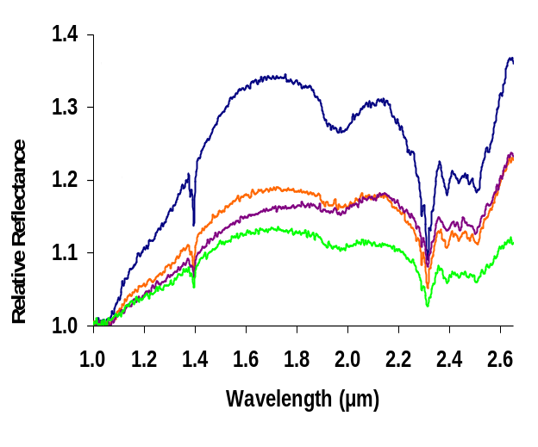
Fig. 2: Olivine (Top) and Anorthosite (Bottom). Notice
spectrum generally is flatter, albedo decreases, and
shallower bands as exposure time increases.

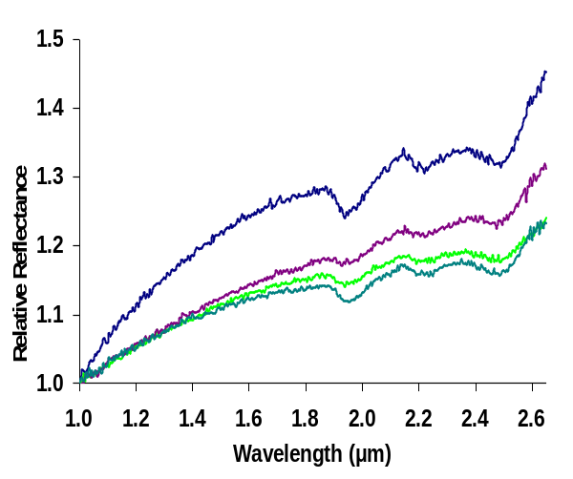
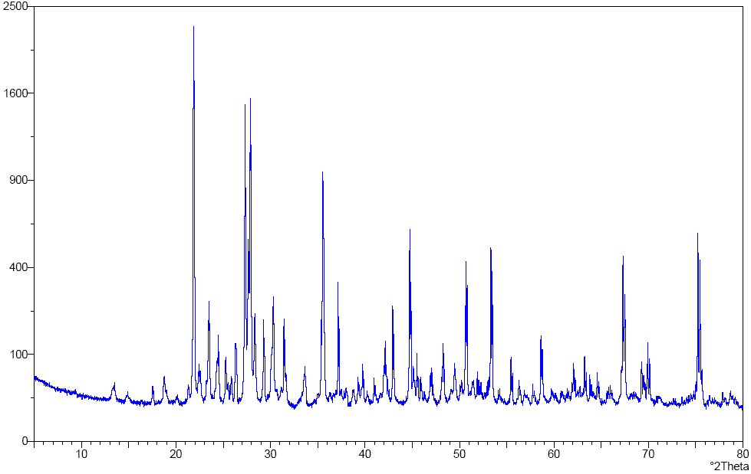

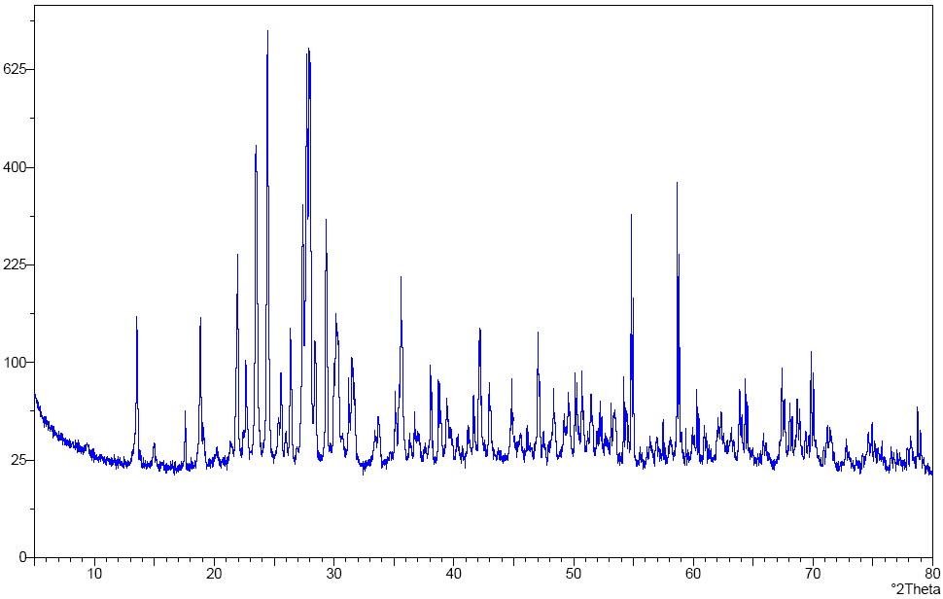Fig 3: XRD results from Anorthosite. Note: unexposed (top) went up to ~2400 “counts” and 8hr exposure only goes up to ~650 “counts”.

Discussion/Conclusion: Alumina was not supposed to darken, but it did. This is an indicator of contamination. Test runs on the ESEM concluded that contamination is mainly from the electrode used in the sputtering unit, a Au/Pd alloy (Fig. 4). The increasingly shallow absorption features (Fig. 5) and destruction of the crystalline structure (Fig. 3) show that there is apparent altering of the composition. These changes could alter remote sensing results which are consistent with the ideas of space weathering. Since results of troilite sample are inconclusive, further testing on a different troilite sample will be done.
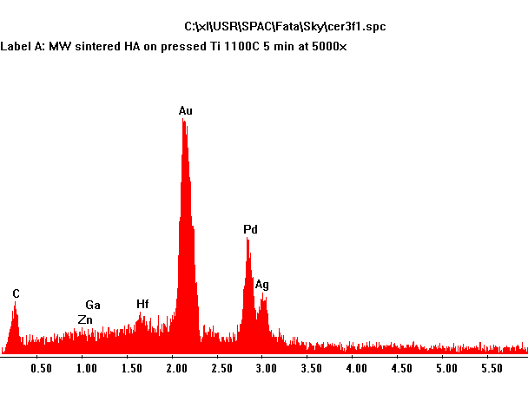
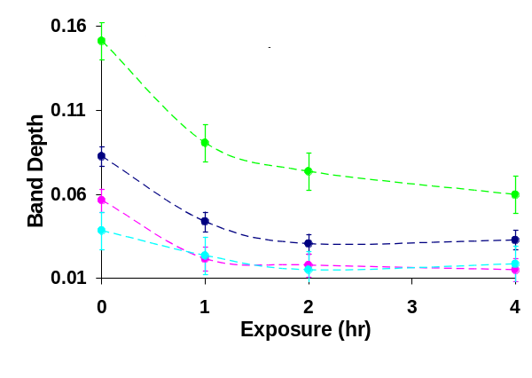
Fig. 5: Band depth of Olivine (Fig. 2 Top) as function of time. Depth of each band decreases after exposure.

Future: Meteorite and more troilite samples will be the emphasis of future tests. Troilite is the major sulfur containing compound found in meteorites and presumably asteroids [2].Testing on troilite will have the emphasis of finding the rate of sulfur loss as a function of time, and allow us to extrapolate and theorize on how long it takes for certain levels of depletion to occur. Attempts to reproduce characteristics found in asteroid spectrums with meteorite samples will also be made. If this can be done, it will greatly strengthen the case of space weathering on asteroids, and may eventually make it possible to create a classification of the amount of exposure it takes to get certain characteristics in particular types of asteroids/meteorites. This will potentially make it possible to determine the age of the surface of an asteroid just by taking its spectrum. Testing on samples will engage the same analysis techniques previously used and include use of a Transmission Electron Microscope (TEM) to gain better resolution of the structure and to gain the ability to penetrate the surface to see how deep the sample has been affected.

Acknowledgments: Dr. Derek Sears, Walter Graupner, Dan Ostrowski, Fatemeh Sedaghatpour, Travis Altheide, and Melissa Jones.

References: [1] Sasaki, S., Hiroi, T., Lunar and Planetary Science 39, 1625-1626, 2008 [2] Sears, Derek W.G. and Kracher, Alfred, Icarus 174, 2005. [3] Wiesli, Rene A., Beard, Brian L. Taylor, Lawrence A. Johnson, Clark M., Earth and Planetary Science Letters 216, 457-465, 2003. [4] McCoy, T.J., Burbine, T.H., McFadden, L.A., Starr, R.D., Meteoritics and Planetary Science . Planetary Science 36, 1661-1672, 2001.

Fig. 4: Contamination identification using ESEM.

